Labor people: Chairman of a collective farm from the Drozhzhanovsky district, who has led his native village and fellow villagers all his life to a decent life
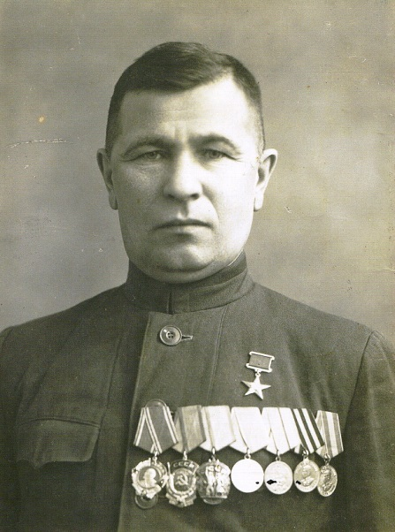
In a village, the life of each person is clearly visible. Good fellow villagers are remembered for many years.
Today, the hero of our “Labor People” column is Lazar Vasilyevich Dergunov, who throughout his life led his villagers to a decent life.
He was born on February 7, 1907 in a village Novyi Ubei of Drozhzhanovsky district. At the age of 8 he entered the Novoubeevsky primary school, but could not finish his studies. The family needed working hands. Lazar Dergunov, as a teenager, began plowing and sowing on horses, helping his father.
Since 1930, he continued his career in the collective farm "Our answer with his fists." Then he was both a livestock collector, and a supply manager and cashier at the Ubeevsky vegetable drying plant. In 1938, the labor collective of the state farm elected him a chairman of the collective farm named after He showed remarkable organizational skills.
Soon the war began, Lazar Vasilyevich left to the front. The Red Army soldier Dergunov participated in offensive operations against the German-fascist and White Finnish troops on the Karelian front. In July 1942 he was transferred to the south-western front, where he took part in the heroic battle for Stalingrad. In the battles near the Beketovka he was wounded. In July 1943 he was demobilized and awarded the medal "For Military Merit."
Despite the serious battle wound, Lazar Vasilyevich returned to his beloved work. In the difficult war years for the country, the workers of its collective farm sent up to 718 thousand pounds of bread, 3300 pounds of vegetables, 1080 pounds of meat and tens of thousands of liters of milk to harvesting centers. More than one million rubles were contributed by the collective farmers to the country's defense fund for the construction of tanks and airplanes.
In first post-war years, the livestock population exceeded the pre-war numbers, and the acreage increased by 220 hectares. At the beginning of 1947, the collective farm joined the Altai collective farmers in the patriotic initiative and became participants in the all-Union competition for high yield. By the end of August, they delivered 12156 pounds of selected grain to procurement points.
The economy has become stronger a year to year. The sturdy farms, grain barns, windmills, haircutters, churn and covered currents were pleasing to the eye. Soon the long-cherished dream of Lazar Vasilyevich came true - a district power station was built. The fame of the Chapayevites crossed the borders of the Drozhzhanovsky district. And that was thanks to the chairman.
During the years of Lazar Vasilievich’s leadership, the collective farm was distinguished by high yields of agricultural crops. The farm introduced progressive forms of labor organization, strengthened the material and technical base of livestock and subsidiary production. The collective farm became the participant of the All-Union agricultural exhibition.
By the Decree of the Presidium of the Supreme Council of March 6, 1948, Dergunov Lazar Vasilyevich was awarded the title Hero of Socialist Labor with the award of the Order of Lenin and the gold hammer. Also, 7 of the best farm workers were awarded the Order of Lenin, 8 - the Order of the Red Banner of Labor, and 21 people - with medals.
In addition, Lazar Vasilyevich himself was awarded the Order of the Red Banner of Labor, the "Badge of Honor" and medals of the USSR. In 1955, he was elected to the Supreme Council of the TASSR.
In 1960, Lazar Vasilyevich wrote a book “We are the owners of the land: Notes of the chairman of the collective farm named after Chapaev.
Lazar Vasilyevich is no longer with us, but the good memory of him lives in hearts of his fellow villagers, and his name is entered in the “Book of Heroes of Labor of the Tatarstan Agricultural Complex”, his bust is installed on the Alley of Heroes of the Drozhzhanovsky District. And in 2007, the book “Descendants of Ubi-Batyr” was published in the Drozhzhanovsky district, dedicated to the natives of the village of Ubeysky rural settlement. You can read about Dergunov on one of the pages of the book.

