Labor people: a beekeeper with 50 years of experience from the Aznakayevsky district
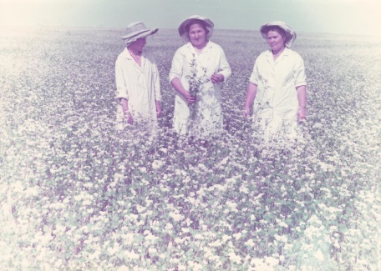
The beekeeper is a difficult, but interesting profession. It is not just a profession, but a way of life. Among the beekeepers there are no indifferent to their work - each of them is passionately in love with his profession, just like today's heroine of our column “People of Labor” - Zaydullina Gasima Barievna, who has been working in agriculture for 50 years.
She was born on April 4, 1950 in the village of Kuchle-Bulyak, Aznakaevsky district. At the age of 16 she started working at the Vakhitov state farm in the Aznakaevsky district. After graduating from secondary school, in 1967 she entered the rural vocational school in the village of Tenki, Kama-Ustyinsky district, studying on "Beekeeper". In 1968, she began working as a beekeeper at the Vakhitov State Farm. Having quickly mastered the profession, soon she managed to increase the number of bee colonies to 100 hive.
Since 2009, Gasima Barievna is the head of private farms in the village of Urmanayevo, Aznakaevsky district.
Gasima Zaydullina has been engaged in her favorite business for over 50 years and works on increasing the number of bee colonies, improving and preserving the quality of the honey produced. So, in 2015, there were 50 bee colonies, in 2016 - 60, in 2017 it increased to 85. Production of marketable honey for the period from 2014 to 2018 from one bee family also increased from 30 to 55 kilograms. 3 tons of honey were produced during the period of 2018.
In addition to the main work Gasima Barievna is engaged in charity. After harvesting, she organizes the distribution of honey to lonely fellow villagers, distributes it in the mosque of Pobeda village, the village of Urmanaevo, in the madrasa at the central mosque of the city of Aznakaevo.
The conscientious work of Zaidullina was marked by municipal, republican awards and valuable gifts. She deserved prestige and respect among beekeepers, fellow villagers and district leaders.
Among her awards are the Silver Medal of the USSR National Exhibition of Economic Achievements, the Certificate of Honor Tatpcheloprom of the Republic of Tatarstan, the Certificate of Honor of the Head of the City Administration Aznakaevo and the Aznakaevsky District, the Certificate of Honor of the Office of Beekeeping of the Republic of Tatarstan, the Letter of Gratitude from the Head of the Administration of the City Aznakaevo and the Aznakaevsky Region, Honorary Diploma of the Office of Beekeeping of the Republic of Tatarstan, the letter of thanks of the Ministry of Agriculture of the Russian Federation.

