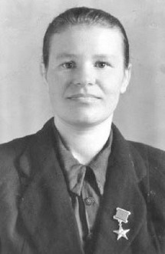
People of Labor: a woman of field brigade of the Tetyushsky district provided record harvests.

Today, the hero of our rubric is Linkova (Vasina) Klavdiya Alexandrovna. Thanks to her, record harvests of winter wheat were gathered during hungry years of the war despite weather conditions.
She was born in 1927 in Narmonka village of Tetyushskiy district. She began her career at the age of 14 on the Novy Mir collective farm. She worked all day long, contributing to the victory. She was awarded by the medal "For Valiant Labor during the Great Patriotic War of 1941-1945."
After graduating an agricultural school in Tetyushi in 1945, Claudia became a foreman in the field crop brigade.
Her department should cultivate the winter wheat. It was grown before the war, but the yields were low. The field farmers were hardly acquainted with technics of its cultivation; there was a strong opinion that local climate was unfavorable for this crop. And yet, Claudia agreed. She read lots of books on agricultural technology, studied the experience of Buinsky district, got acquainted with the long-term experiments of Kazan breeding station and Kuybyshev experimental field.
They began the work. Selected seeds were laid in prepared soil. Soon the area was full of sprouds. In the spring, the crops were fed with organic and mineral fertilizers. By the harvest there was a great cornfield. Those who looked incredulously at the efforts of the department could not say a word.
It turned out that the yield was 28.6 centners of wheat. And 30.14 centners of rye from each hectare! These were unprecedented numbers, because the best for the collective farm "New World" in terms of yield took only 16 centners in 1939!
In 1948, Claudia Alexandrovna Linkova was awarded the title Hero of Socialist Labor with the award of Order of Lenin and the Sickle and Hammer gold medal.
In the 50s - 70s she worked as a livestock breeder, farm running, took part in social work. Compatriots elected Claudia Alexandrovna as deputy of Supreme Council of the TASSR, and her name was noted in the Book of Heroes of Labor of the Agro-Industrial Complex.

