Kalimullin Rifkat Kalimullovich, honored mechanic of Kaibitskiy district.
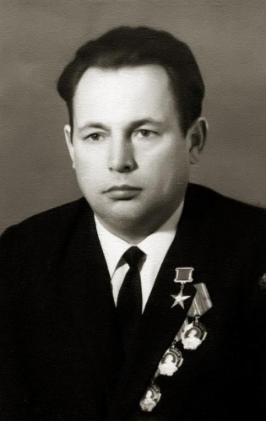
Today, the hero of our story is Kalimullin Rifkat Kalimullovich. He was born 5 April 1927 in the village of Burunduki, Kaibitsky District of Tatarstan. Since childhood, the smart boy surprised fellow villagers - he could fix the clock, assemble a motor of the aerosled. People explained it by the fact that father of Rifkat was a known master as well.
During the war years, native village of Rifkat became empty, men left to the frontline. So did his father. In 1942 Rifkat becomes an assistant of combine operator in the Muralinsk MTS. A year later, hard-working young man was let to the steering wheel of combine. Army needed not only shells and guns. Bread also became a weapon of war. Kalimullin was one of best combiners of MTS. At a rate of 180 hectares, he cut more than 360 hectares. In 1945, the production of the season raised to 700 hectares.
Rifkat showed a truly engineering approach. In 1949, having improved the header of the combine, he harvested a crop on 1,300 hectares. It was one of the best results in the country. The first award, the Order of Lenin, worthily crowned his work.
The next cutting Rifkat overlaps his record and gets again awarded the Order of Lenin. In 1951 he cats the corn on 1366 hectares. Rifkat Kalimullovich Kalimullin is awarded the title Hero of Socialist Labor. And this is a man of 24 years old!
In the same time Rifkat graduates from evening school and enters the Kazan Agricultural Institute in 1953. He graduates with the red diploma and becomes a teacher in this university. He studies by correspondence at the Timiryazev Academy, he presented his thesis and became a candidate of technical sciences.
In 1966-1969 Rifkat Kalimullovich works as chief engineer of the republican association “Agricultural Equipment”, then until 1987 he is in charge of the mechanization department of the NGO “Niva Tatarstan”. He is an honored innovator of the RSFSR, Honored Inventor of the USSR, the author of a number of textbooks. He also is an honored Mechanic of Agriculture of the TASSR, which, by the way, celebrates its 100th anniversary this year.
Today, he is no longer with us, but his fame is immortalized in the Book of Heroes of Labor of the Tatarstan agro-industrial complex.

