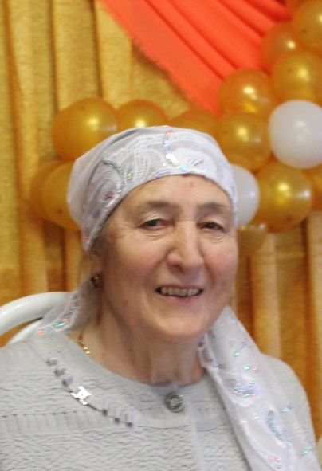
Today, the heroine of our rubric is Gulbika Galeevna Karimova, who worked as a milkmaid for many years
The profession of a milkmaid is hard and painstaking work. The well-being of any farm depends on their work, since milk is one of the main sources of income. And the milkmaid is still the main figure in milk production. Every day, no matter weekends and holidays, the milkmaids wake up at 4 o'clock in the morning. At five p.m. they are again on the farm. And every day is the same for many years.
Gulbika Karimov was born in 1938 in Uzyak, Tyulyachinsky District. After graduating from the seven-year school, she started working at the dairy farm. Labor of milkmaids then was very hard. Everything was done manually. However, in the first year, the results of her work were impressively high.
In 1965, life in the village abruptly changed. Mechanization came to the farm, new technologies were introduced. The number of cows in the group served by Karimova almost doubled. In 1966, for the compliance of social obligations, she was awarded the Order of Lenin.
In 1968, she set the task to get at least 4500 kilograms of milk from each cow and fulfilled it, winning the title of “The best milkmaid of the area”. In the same year, she brought the milk to 5549 kg, which was two times higher than the average indicator. For that she was awarded the title “Best Milkmaid of the Tatar ASSR”. For the fulfillment of plans for the VIII Five-Year Plan, Gulbika Galeevna was included into the Republican Book of Honor.
“Animals should not be treated rudely. Of course, the cow does not understand speech, but catches intonation perfectly. And if a person treats her well, then she will give more milk”, says Gulbika Karimova. She participated in the USSR Exhibition of Economic Achievements and got medals. She was a member of the CPSU, a delegate of the XXV Congress of the CPSU, engaged in social activities. Until 1993, she worked as a milkmaid in the Leningrad Primary Petrochemical Plant named after Lenin.
April 6, 1971 Karimova was awarded the title Hero of Socialist Labor with the award of the Order of Lenin. Gulbika Karimov is also a laureate of the 1982 USSR State Prize for increasing the production of high quality livestock products, applying advanced technologies and increasing labor productivity.

