Working people: half a century behind the wheel of a tractor
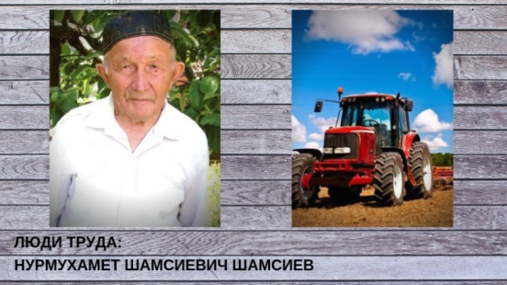
Today, the hero of our “People of Labor” rubric, in which we write about ordinary people who have gained honor and respect with their everyday work, is Nurmukhamet Shamsiyevich Shamsiyev from the Tukayevsky district, who worked as a mechanic for 50 years.
Nurmukhamet Shamsiyev was born on June 27, 1934 in the village of Urguda, Menzelinsky District, now of the Tukayevsky District of the TASSR, in a large peasant family. Nurmukhamet grew up in difficult for our country wartime, he managed to finish only 4 classes. Even before serving in the army, despite the young age, in the post-war period, he actively participated in collective farm production along with adults. Upon returning from the army, he did not leave his native village, did not look for happiness in other places, stayed in his homeland, in his father’s house.
After serving in the army, he graduated the general tractor driver courses. He began his labor activity as a plowman. Nurmukhamet worked on various brands of tractors and combines and in the rain and in the snow and from morning till night. In those days, there were few tractors, so they worked on the night shift. Then the guy himself learned to drive a tractor. After studying mechanization courses in Naberezhnye Chelny, he received a tractor driver license. From early spring to late autumn he worked on the field. He gained experience working with experienced machine operators, and also learned a lot from his father.
At first, he worked on simple tractors, and later, an easily-managed machinery with hydraulic equipment appeared, as well as tractors with a starter. During all his labor activity, and for almost 52 years, he twice sat down at the new Belarus tractor. Nurmukhamet very carefully treated them, kept in complete purity and order.
For all the time of work, Nurmukhamet Shamsiyev showed himself as a responsible, hard-working and demanding worker and employee. The advanced machine operator was awarded many times with honorary diplomas and certificates. It is impossible to count all the letters that were handed to him by the leadership of the district and collective farm.
Nurmukhamet Shamsiev - labor veteran. At 85, he serves as an example for residents of the districts, sharing his rich experience and giving advices.
Now he holds chickens and geese, grows vegetables and fruits in the garden, potatoes, beautiful flowers. He is also engaged in the organization of a small village holiday, which is held annually in the village of Urguda, and always helps to mow the grass on the Maidan.

