Labor people: The best calf attendant of the Tatar SSR and the best bird attendant of Nizhnekamsk region
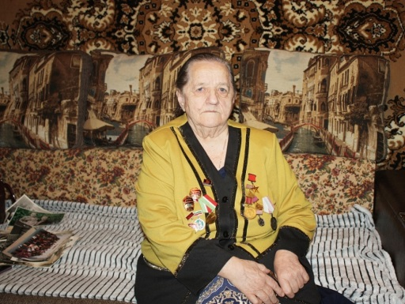
There are talented musicians, artists, engineers, production managers in the world, but there are also talented workers. Today, the heroine of our column “People of Labor” is Malysheva Klavdiya Filippovna.
Klavdiya Malysheva was born on July 2, 1936 in the village of Kalinovka, Tukayevsky district. When Claudia Filippovna was six months old when her parents moved to the village of Krasny Klyuch in the Nizhnekamsk District. The settlement was the central manor of the state farm of the same name, where Claudia Filippovna’s parents — simple peasants — worked.
The girl joined the work early, helping her mother who worked as a calf attendant. With the beginning of the Great Patriotic War, her father went to the front and in 1942 he died near Stalingrad. No matter how hard it was for a single mother to raise two daughters, she tried to make Claudia finish the local eight-year school plan. Then the girl showed character, insisting that she should go to the farm to work next to her mother. She started working at the age of 16, she was determined to care for newborn calves. Claudia Filippovna, with all her usual conscientiousness, performed the assigned work. Thus, for achieving high performance in the socialist competition in 1959 at the age of 23, she was awarded the honorary title “The Best Calf Attendant of the Tatar ASSR”.
Then all the cows and calves from the farm were transported to Afanasovo, and the Red Key began to develop poultry farming, and a large poultry factory was built. Since 1960 Claudia Filippovna began to work as a bird attendant.
“At the very beginning, with my partner we had several thousand hens. We collected eggs from the ribbon by hand, carried them to the warehouse in baskets, counted there. About 250 eggs per hen per month. We were given a big plan, but we over-performed it. We tried to take young chickens, they gave eggs quickly and in large quantities. Of course, nothing would have happened without good care and quality food. At first the birds were kept on the floor, then they were kept in cages, and soon the whole process became mechanized, ”says Klavdia Filippovna.
Natural diligence and internal need to perform everything in the best way helped her to consistently achieve impressive results in raising the egg-laying capacity of chickens from year to year.
“Of course, we worked hard, woke up at 4 am. Fulfilled all indicators. When our factory was closed, I have been already retired. It was a pity. You go on a tram, you look at the place where the poultry farm used to be, and you remember how life passed at this enterprise, ”says Klavdiya Filippovna.
Until she left for a well-deserved rest upon reaching the retirement age, Klavdiya Filippovna did not lower the bar of labor prowess. In 1986 she was awarded the title of the best poultry attendant, as well as the bronze medal of the USSR Exhibition of Economic Achievements. And today, a labor veteran is not shy away from public affairs.
“I am old, and I do not regret at all that life has passed this way. We worked a lot, but not for the sake of records and awards, although I have been working for more than 40 years. Work was a part of our life, and we had no colleagues, but friends, with whom we shared both joys and sorrows. I don’t know, maybe because of this, the work didn’t seem to be a kind of duty, but it was a joy, ”Klavdiya Malysheva shares her memories.
By decree of the Presidium of the Supreme Soviet of the USSR dated March 22, 1966, for the achieved success in the development of animal husbandry, Claudia Filippovna was awarded the title Hero of Socialist Labor with the award of the Order of Lenin and the Serp & Molot gold medal for the achieved progress in the development of animal husbandry.

