People of Labor: a sheep breeder from the Bavly District

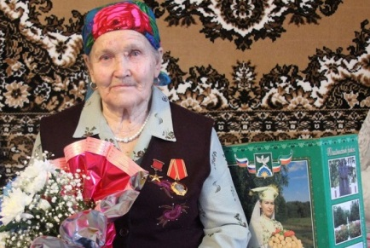
Today, the hero of our “People of Labor” rubric is Zaripova Tausiha Garayevna, who has found her vocation in the sheep farming industry. Tausiha Garayevna was born in 1930 in the village of Murtaza, Bavly District. Her father worked as an agronomist at the Kirov collective farm, and her mother worked as an ordinary collective farmer. Tausiha's childhood overlapped with the Great Patriotic War, and as a girl, along with all her rural peers, helped adults, mostly women, as much as she could, to do hard peasant work in the fields and farms.
One motto: “Everything for the front, everything for victory!” was the motto that all lived by then. The medal for “Valiant Labor in the Great Patriotic War of 1941-1945”, which was awarded to Tausiha, serves as a reminder of that difficult time.
She found her vocation in the sheep farming industry, to which she gave about three decades of her life. For the past twelve years before retirement, she headed a large sheep farm. Under her leadership and her great diligence, the farm became the best among the others on the Kirov collective farm. Year after year it achieved high rates in wool production. As confirmation of this - T. G. Zaripova has been awarded: the "Badge of Honor", the medal "For Labor Difference" and the medal of the USSR Exhibition of Economic Achievements.
In April 1971, Tausiha Garayevna Zaripova was awarded the title Hero of Socialist Labor with the award of the Order of Lenin and the Sickle and Hammer gold medal, for her high results in fulfilling the five-year plan.
Tausiha Zaripov has always been distinguished by great diligence, high human qualities, exceptional vitality and optimism. The fond memory of Tausiha Garayevna Zaripova will remain in our hearts for a long time.

