The hero of labor from Nurlat district in whose honor the street was named

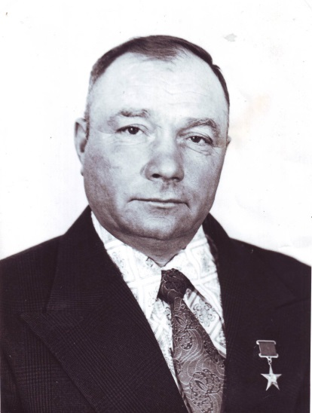
Today, the hero of our column “People of Labor” is Zakharov Nikolai Ivanovich. He was born on September 20, 1929 in the village of Old Chelny of the Oktyabrsky District in a peasant family. He graduated from the rural seven-year school on the second year of the Great Patriotic War. The boy had to help the adults who remained on the work in the fields and farms.
Returning from the army, he passed the courses of tractor drivers in Bugulma SPTU and then he worked in the fields of his own collective farm. Everything went well for Nikolay, and one day the chairman of the collective farm suggested to head the lagging pig-breeding farm. Zakharov took full responsibility for hundreds of animals. Soon the business went on the rise, and when the farm joined with the farm "Struggle", Zakharov took under his control the already enlarged pig farm.
The perseverance and energy that Nikolai Ivanovich gave to the his job every day began to pay off: in district and republican reports the collective farm was on leading positions on the meat weight gain and delivery to the state. The five-year plan (1966-1970) for the delivery of livestock products was exceeded.
For this high achievement, the decree of the Presidium of the Supreme Soviet of the USSR of April 8, 1971 awarded Nikolai Ivanovich Zakharov with the title of Hero of Socialist Labor with the award of the Order of Lenin and the Sickle and Hammer gold medal.
In subsequent years, he served as chairman of the Starochelninsky Village Council of People's Deputies, deputy chairman of the Sindryakov collective farm. He was elected a deputy to the Oktyabrsky District Council of People's Deputies.
The street named Zakharova in Nurlat is named after him and his name is in the Book of Heroes of Labor of the agro-industrial complex.

